EMERTXE TRAINING PROJECT DOCUMENTATION FRAMEWORK

REQUIREMENTS & DESIGN

DOCUMENT

# 1 Overview

## 1.1 Purpose

The purpose of the document is to understand the requirements of “Home Automation using Arduino (picsimlab)and Blynk application ”. This document will be used by the students to develop the project. This document will also be used for requirement validation.

## 1.2 Scope

The Home automation should be simulated on the picsimlab simulator, Blynk iot mobile applications used to control the devices . Should be able to control the lights, temperature of the home , inflow and outflow of water in the water tank.

# 2 Assumptions, Dependencies, Constraints

## 2.1 Assumptions

*Describe the assumptions that can affect the requirements specified in this document.*

All the peripherals are simulated and no real time objects are interfaced .

## 2.2 Dependencies

*Describe the dependencies that can affect the requirements specified in this RDD.*

Based on Blynk Mobile app

## 2.3 Constraints

*Describe the constraints that can affect the requirements specified in this RDD.*

None

3 Requirements

# 3.1 Functional Requirements

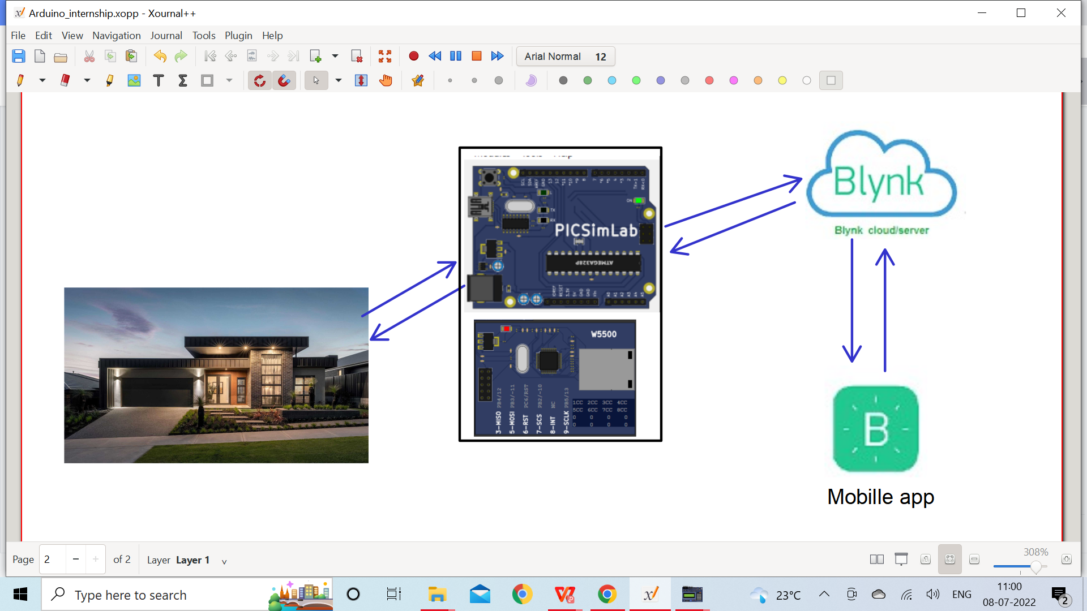

## 3.1.1 Garden lights control

Description :

Read the LDR sensor value, based on the reading from LDR, vary the brightness of the led, which resembles controlling garden lights based on the availability of sunlight.

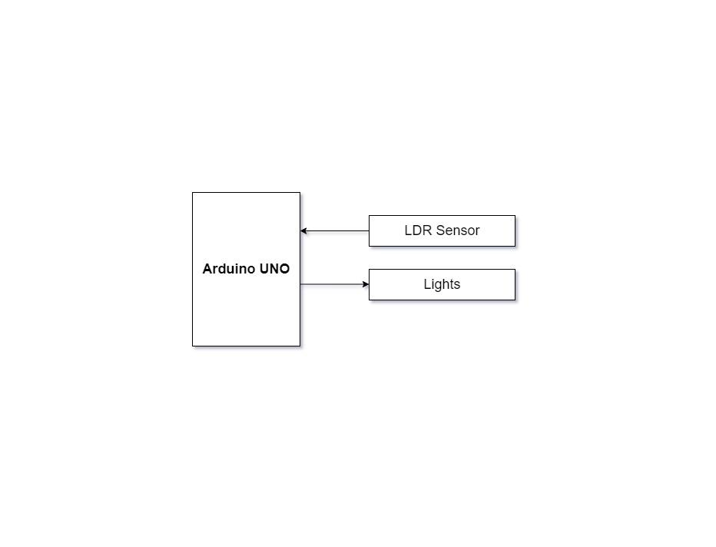

|  |  |
| --- | --- |
| Requirement No | 1 – Garden lights control |
| Description | Inputs - LDR Sensor |
| Process - Read the LDR sensor value, based on the reading from LDR, vary the brightness of the led, which resembles controlling garden lights based on the availability of sunlight. |
| Output - Garden Lights |

## 3.1.2 Temperature Control System

Description :

The temperature control system consists of a heating resistor, an LM35 temperature sensor, and a cooler. Which resembles the temperature control system at home. Read the temperature from the temperature sensor LM35 and display it on the CLCD. Control the temperature of the system by turning ON/OFF the heater and cooler through the Blynk IOT mobile app .

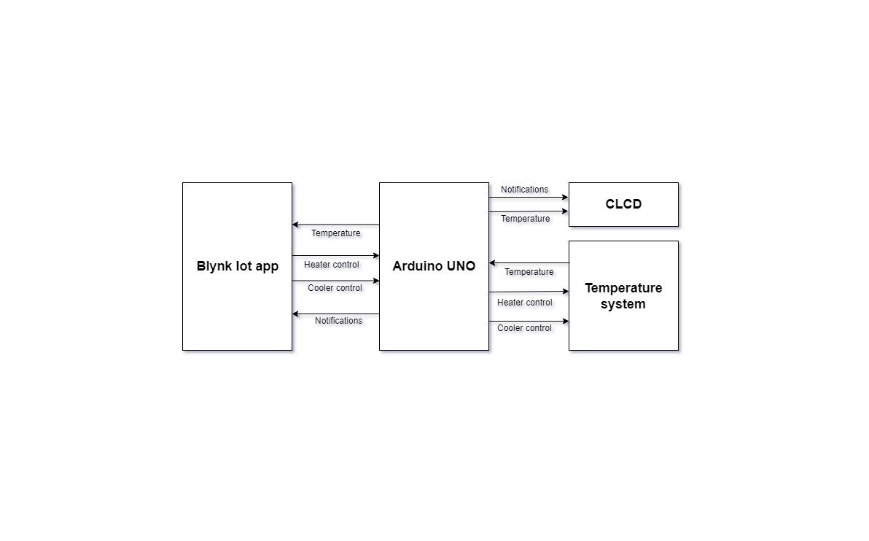

|  |  |
| --- | --- |
| Requirement No | 2 – Temperature Control System |
| Description | Inputs - Temperature Sensor. |
| Process - Read Temperature from temperature sensor LM35. |
| Output - Display Temperature on Gauge Widget,  Display Temperature on CLCD. |

|  |  |
| --- | --- |
| Requirement No | 3 – Cooler Control System |
| Description | Inputs - Button Widget(Cooler button) on Blynk iot app . |
| Process - Detect the change in the logic level |
| Output - if the Button widget is at logic high, turn ON the cooler.  if the Button widget is at logic low, turn OFF the cooler. |

|  |  |
| --- | --- |
| Requirement No | 4 – Heater Control System |
| Description | Inputs - Button Widget(Heater button) on Blynk iot app . |
| Process - Detect the change in the logic level |
| Output - if the Button widget is at logic high, turn ON the heater.  if the Button widget is at logic low, turn OFF the heater. |

|  |  |
| --- | --- |
| Requirement No | 5 – Threshold temperature control |
| Description | Inputs - Temperature sensor |
| Process - Read and compare the temperature with 35 degrees |
| Output - if the temperature is more than 35 turn OFF the heater and send notification to Blynk IOt app and display the same on the CLCD.  . |

## 3.1.3 water tank inlet and outlet valve control

Description :

Read the volume of the water in the tank through Serial Communication and display it on the CLCD, control the volume of the water in the tank by controlling the inlet and outlet valve, by sending commands through serial communication. Display the volume of water in the tank on the CLCD.

## 

## 

|  |  |
| --- | --- |
| Requirement No | 6 – Display the volume of water in the tank |
| Description | Inputs - Serial tank. |
| Process - Read the volume of the water in the tank by sending commands through serial communication. |
| Output - Display the volume of the water on Gauge Widget  Display the volume of water on CLCD. |

￼

|  |  |
| --- | --- |
| Requirement No | 7 – Inlet valve control |
| Description | Inputs - Button Widget(Inlet valve button) on Blynk iot app . |
| Process - Detect the change in the logic level |
| Output - if the Button widget is at logic high, turn ON the inlet valve by sending commands through serial communication.  if the Button widget is at logic low, turn OFF the inlet valve by sending commands through serial communication. |

|  |  |
| --- | --- |
| Requirement No | 8 – Outlet valve control |
| Description | Inputs - Button Widget(outlet valve button) on Blynk iot app . |
| Process - Detect the change in the logic level |
| Output - if the Button widget is at logic high, turn ON the outlet valve by sending commands through serial communication.  if the Button widget is at logic low, turn OFF the outlet  valve by sending commands through serial communication.. |

|  |  |
| --- | --- |
| Requirement No | 9 – Control the volume of water in the tank |
| Description | Inputs - Serial tank. |
| Process - Read the volume of the water in the tank by sending commands through serial communication. |
| Output - if the volume of water in the tank is less than  2000 ltrs turn ON the inlet valve, and send notification to the blynk mobile app and display the same on the  CLCD. |

3.2 User Interfaces

BLYNK Application

Blynk was designed for the Internet of Things. It can control hardware remotely, it can display sensor data, it can store data, visualize it and do many other cool things.

Create widgets on Mobile blynk application

**Button widgets** to control heater, cooler, inlet valve , outlet value.

**Gauge widgets** to display temperature and volume of the water in the tank on the mobile application

**Terminal widgets** to display the notifications whenever threshold is crossed like

“Temperature is more than 35 degrees”, “” turning OFF the heater”, “water level is full “

“Water inflow disabled”

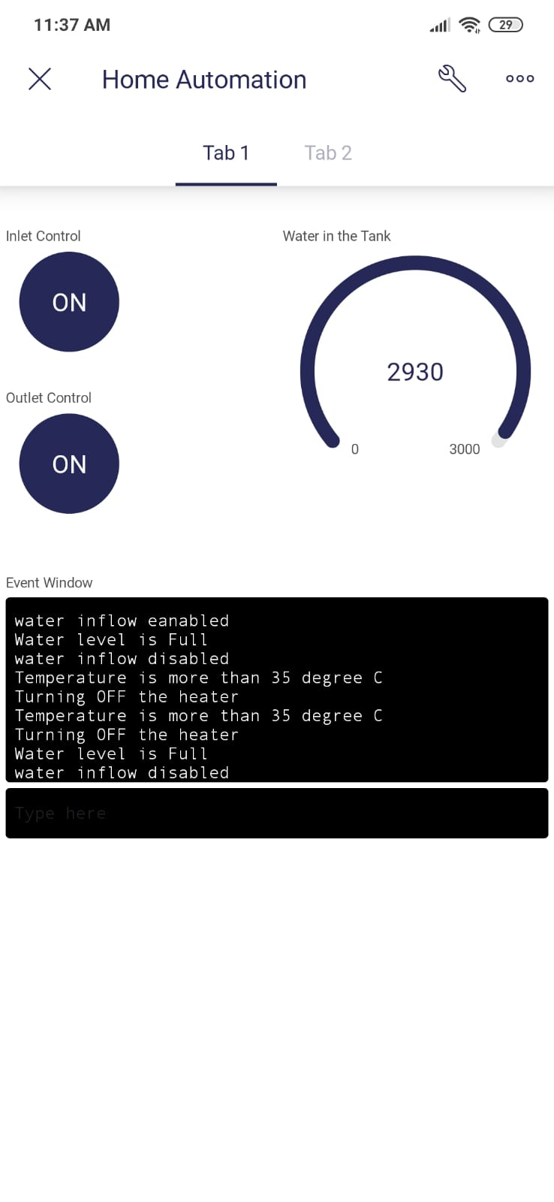

Fig 2 : (Tab1) Button widgets to control inlet valve, outlet valve, gauge to display volume of water in the tank and terminal to print the notifications.

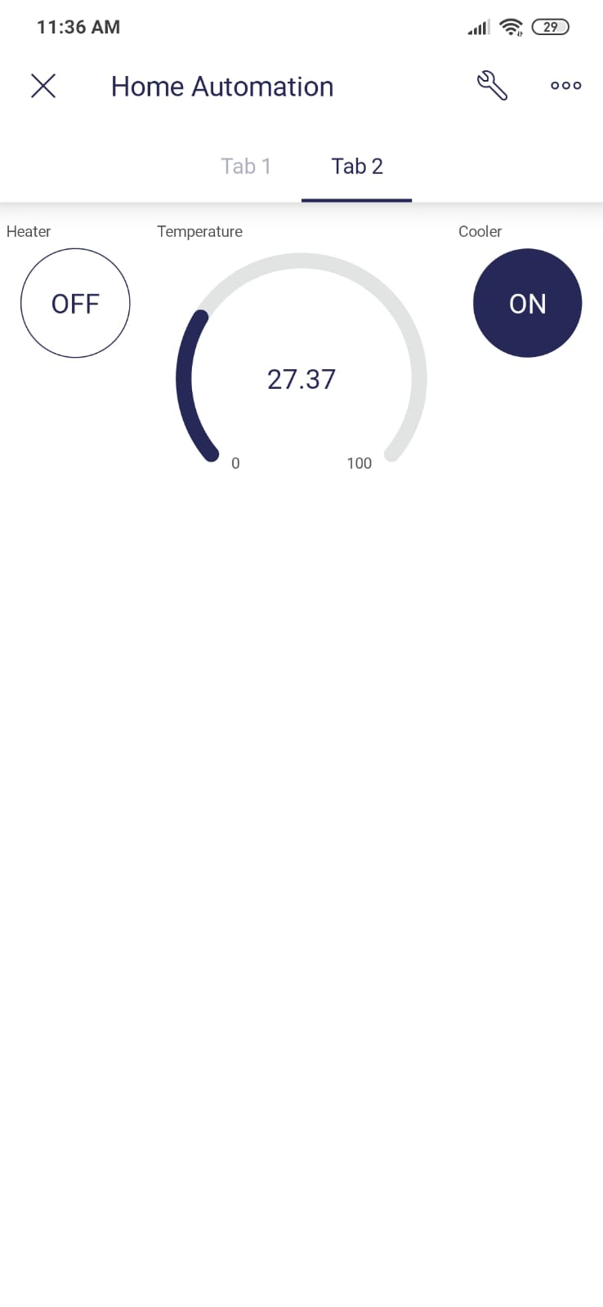

Fig 3:Tab2 Button widgets to control the heater, cooler and gauge widget to display the temperature.

## Threshold control

When the heater is ON if the temperature rises above 35 degree celsius then heater should turn OFF automatically and message “Temperature is more than 35 degree celsius Turning OFF the heater” should be displayed on the virtual terminal, “HT_R OFF” on CLCD.

When the water in the tank is full, turn off the inlet valve automatically and display “water level is full water inflow disabled” .

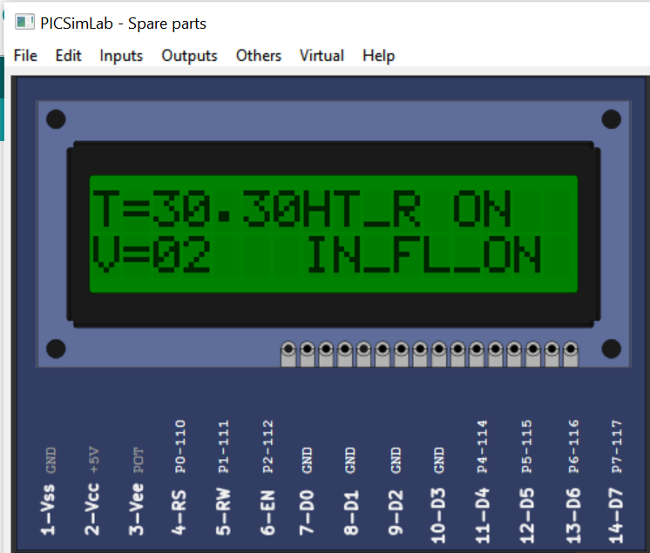

Fig 4 : Notifications on CLCD



Fig 5 : Notifications on Virtual terminal

# Conclusion

Using BLYNK Iot application and Picsimlab simulator, simulated home automation, where LED, temperature system, Serial tank resembles Light, Heater, Cooler and Water tank in real time.

CLCD acts like a dash board used for displaying the events, Widgets from Blynk Iot app like button widgets are used to control heater, cooler and inlet valve, outlet valve.

Gauge widgets to display the temperature and volume of the water.